< CSE211 Web Programming, Fall Semester 24/25 >

< Assignment #1: Websites conceptual Design and mock-up >

< 222102343, Mariam Ahmed Mohamed Abdelrahman >

**1. Outlining Web 2.0 to Web 4.0 Features Every phase of the web's development signifies a unique change in user interaction, technological prowess, and corporate and societal applications.**

Web 2.0 (2004 onwards): Often referred to as the "social web," Web 2.0 places a strong emphasis on social networking, user-generated content, and interaction. Through blogs, wikis, and social media platforms, it completely changed how users contribute to content creation.

Web 3.0 (from 2010 onwards): Also referred to as the "semantic web," Web 3.0 seeks to make the web experience more meaningful by empowering machines to comprehend and analyse data. Blockchain, AI, and machine learning are important technologies that enable improved data accuracy and decentralisation.

Web 4.0: Still in its infancy, this idea is frequently referred to as the "intelligent web." It is anticipated to arrive around 2030. In Web 4.0, there will be significant levels of machine autonomy and interconnected smart devices. Through data analysis and platform integration, AI systems will be able to anticipate future needs and comprehend user needs proactively.

**2. Important Aspects of Web 2.0 and Network Power**

Content Created by Users: Users were able to produce, share, and edit material on websites like Wikipedia, YouTube, and Facebook, which promoted previously unheard-of levels of cooperation.

Social networking: The emergence of social media behemoths during Web 2.0 changed social dynamics by connecting billions of users worldwide. These networks' power resides in their capacity to build communities, cultivate relationships, and generate group influence.

Collaboration through Empowerment: Knowledge sharing was made possible by tools such as blogs, wikis, and forums, which connected people to resources of shared knowledge and democratised access to information.

Because businesses could now interact directly with their customers, gather feedback, and foster brand loyalty through digital word-of-mouth, these network-driven features revolutionised commercial strategy.

3. Web 3.0's Key Features and the Strength of Knowledge and Data Connections

Semantic Understanding: RDF (Resource Description Framework) and OWL (Web Ontology Language), two technologies that aid machines in comprehending the context and connections between data elements, brought about a new level of machine understanding with Web 3.0.

Decentralisation: As demonstrated by Web 3.0 apps like Bitcoin and Ethereum, blockchain and cryptocurrencies sought to lessen centralised control and give people more control over their data and finances.

AI and Personalisation: By customising user experiences, machine learning algorithms improve the relevance of content. This has resulted in targeted advertising and personalised content recommendations on websites such as Google and Netflix.

This phase enabled businesses to make data-driven choices, improving client happiness and stimulating advancements in industries including healthcare, banking and education.

Key Features of Web 4.0 and the Strength of Intelligence Connections

The Fourth Generation of the Network- Developed AI systems and IoT devices begin to function in a connected space where users are practically unnecessary and machines perform the speaking, the decision making as well as the predictive work without the help of the users.

Predictive Intelligence: Shaped by infrastructure that is purposefully data driven, Web 4.0 manages to fulfill its objective which is anticipating a situation and generating solutions even before there’s a need like an automated system of wellness tracking.

Virtual and Augmented reality: A major contribution that Web 4.0 will play in Virtual and Augmented applications will be the expansion of the scope of practice, integration of physical and digital competences and presence, as well as enhancement of many areas including marketing, and training through experiential stimulation.

This approach, which is driven by intelligence, is however likely to result in disruptive effects in business as routine work driven by AI would be undertaken by systems leaving people the more critical thinking aspects.

Importance of Collective Intelligence, Social Networking, Social Media and Social Bookmarking

Collective Intelligence: The insights of users are used to solve problems on platforms such as Wikipedia and Reddit, indicating the presence of the crowd’s wisdom.

Social Networking and Media: Such social networks as Twitter and LinkedIn extend the scope and impact of the brand in essence by making it possible to interact in real time and analyze trends.

Social Bookmarking: Diigo and Pocket and other services enable users to sort and tag content and files and make them public, and the information search and content retrieval are advanced.

By and large, these tools help businesses to gain an insightful image regarding the likes of the consumers leading to better marketing and customer relationship strategies.

Self-Sustainable Future and This Year’s Business Plans

Most importantly, as the businesses apply these web technologies, the following additional benefits are achieved:

Data-Empowered Business Models: Conducting analysis of user data increases the knowledge and understanding of the target audience and their needs leading to a cycle of new product development.

Smart Advertising: Providing Advertising 4.0’s burning desire for AI technologies makes marketing more precise and assists with engaging audiences while boosting user retention.

Trust and Risk Mitigation: The network or ledger in the Web 3.0 that uses the blockchain technology can be applied in transacting securely and effectively, this helps Information Systems reduce the risk of frauds and gain consumer trust.

Requisite Aligned with the Cybersecurity Professional as a Technology Drafter of Last Resort

In a wider scope of cybersecurity, Web 3.0 and Web 4.0 technologies offer the following beneficial tools:

Fraud Lessening through Blockchain Technologies for Secure Transactions: The incorporation of blockchain technology in transactions will effectively combat fraud owing to the ability of the technology to maintain secure transaction records.

Vulnerabilities Identification and Attacks Prevention Through Monitoring Driven by AI: Web 4.0 Ai will be able to scan systems actively for vulnerability to possible attacks promoting quicker response time.Securitized Privacy through Decentralization: With the influence of the decentralized platforms provided by the Web 3.0, the chances of suffering data breaches would quite considerably go down targeting a secure provision of user data from centralized attacks.

2.3.2:Website Planning

1-Define the purpose of your intended website; it might be about a favourite hobby or subject, family business, church, mosque or club, a company etc.

>> The purpose of *Habitree* is to provide a cozy, community-centered platform for individuals to cultivate positive habits in various areas of life, such as personal growth, health, spirituality, productivity, and relationships. Inspired by the idea that habits are like seeds that grow over time, This website is designed to encourage personal development while fostering a supportive environment where friends can join, encourage each other, and grow together.

2- What would you like the website to accomplish

>> I would like *Habitree* to accomplish three main goals: Encourage Personal Growth, Foster a Supportive Community, Make Habit-Tracking Enjoyable and Beautiful.

3- Who is your intended audience

>> **Individuals Seeking Personal Growth**: People who are interested in building positive habits, improving various areas of their lives.

4- What opportunities, problems, or issues does your planned website address

>> *Habitree* addresses several opportunities and common challenges people face with habit-building and personal growth: **Opportunity for Gentle Habit-Building**, **Creating a Supportive Community**, **Making Habit-Tracking Enjoyable and Visual**, **Encouraging Holistic Growth Across Different Areas**, **Encouraging Reflection and Purposeful Growth**.

5-What kind of content could be incorporated on your website

>> Habit Categories and Examples, Motivational Content, User Progress and Visual Content, Personal Reflection and Journaling, etc.

6- How will the site serve the client

>> *Habitree* serves its clients by transforming habit-building into an enjoyable, supportive journey. It helps them cultivate positive habits in a cozy, community-focused environment that promotes personal growth, connection, and well-being.

7-What is the best method for the user to do what is wanted

>> The best method for *Habitree* users to effectively build and track their habits within the cozy, garden-inspired theme is a **guided, visual, and community-centered approach**.

8-How will users find the functions

>>**Direct Navigation and Organized Tabs** make essential functions easy to locate.

**Guided Walkthroughs for New Users** highlight key features and how to use them.

**Visual Cues and Icons** for habit tracking, friend interactions, and progress indicators simplify the experience.

**Clear Labels and Buttons** within each section (like “Plant This Seed” or “Water Friend’s Habit”) ensure functions are intuitive and easily accessible.

9- How will the results of the function be received

>> On *Habitree*, the results of each function are designed to be received in a visually engaging, supportive, and motivational way that aligns with the garden theme.

10- What will the receiver do with the received entries

>>**Celebrate and Reflect** on habit milestones, badges, and personal growth.

**Reciprocate Friend Support** to strengthen community ties.

**Adjust Goals and Add New Habits** based on their progress.

**Customize and Personalize** their garden using rewards and decorative elements.

**Participate in Challenges** to stay engaged and focused.

**Use Motivational Prompts and Reminders** to stay inspired and re-engage with their habits.

11- How will the receiver deal with results

>> will deal with the results of their habit-tracking journey by actively engaging with visual progress updates, reflecting on milestones, and using achievements as motivation.

12- What follow up will be needed

>> **Habit Reminders and Milestone Celebrations** keep users engaged and feeling accomplished.

**Community and Friend Support Updates** build a sense of shared progress and mutual encouragement.

**Reflection Prompts and Goal-Setting Reminders** allow users to stay mindful of their growth journey.

**Re-engagement Efforts for Inactive Users** encourage returning to habits.

**User Feedback and Input Collection** ensure continuous improvement and user-centered updates.

13- List atleast two related or similar sites found on the web. Explain why you chose them

>> **Habitica:**

Why Chosen: Habitica gamifies the process of habit-building by turning tasks and habits into a role-playing game. Users create custom avatars, complete tasks to earn rewards, and level up their characters as they make progress. Habitica also offers a community element, allowing users to join groups and challenges with friends.

**Fabulous:**

Why Chosen: Fabulous is a wellness and habit-tracking app focused on building healthy routines. It guides users through scientifically-based daily routines, offering personalized recommendations, challenges, and motivational content to help them establish habits in areas like health, productivity, and mindfulness.

14- Planning analysis sheet:

a-Website goal: The goal of *Habitree* is to create a cozy, supportive, and visually engaging platform where users can cultivate positive habits across various areas of their lives. By transforming habit-tracking into a garden-inspired experience, *Habitree* aims to make personal growth feel natural, enjoyable, and sustainable. Through visual progress tracking, community encouragement, and motivational content, *Habitree* seeks to foster a sense of connection and commitment, empowering users to grow alongside friends, celebrate their achievements, and build lasting, meaningful habits in a nurturing environment.

b-Working Titles: ACCOUNT, SETTINGS, FRIENDS, MY GARDEN, SEEDS1, SEEDS, OUR ROOT.

C- Content description of each page: **Home**: A welcoming page that introduces *Habitree*’s mission of growing positive habits in a cozy, garden-inspired community. Featuring a friendly invitation to join, start planting habits, and connect with others on their journey.**My Garden**: Your personal space where each habit is a seed that grows with your progress. Watch your habits sprout and bloom, celebrating each step forward in your journey.**Pick Your Seed (Habit Library)**: Browse through categories of habits, each represented by a “seed bag.” Select the seeds you want to plant and start nurturing habits in areas that matter to you.**Friends**: A community page where you can connect with friends, send encouragement, and water each other’s habits to support growth together.**Our Roots (About Us)**: Learn the heartwarming story behind *Habitree*, our mission inspired by growth, connection, and the meaning of community. **Settings**: A personalized hub for updating your profile, managing notifications, setting preferences, and customizing your garden’s look and feel.

d-User Forms to collect information:**Registration Form:** To create user accounts, allowing for personalized habit-tracking and community engagement, **Habit Addition Form**: To allow users to add and customize habits in their *My Garden* section. **Friend Invitation Form:**To connect users with friends for mutual encouragement and support, **Feedback and Reflection Form**: To gather reflections on habit progress and collect feedback for platform improvement, **Profile and Settings Form**: To allow users to update personal information, preferences, and account settings.

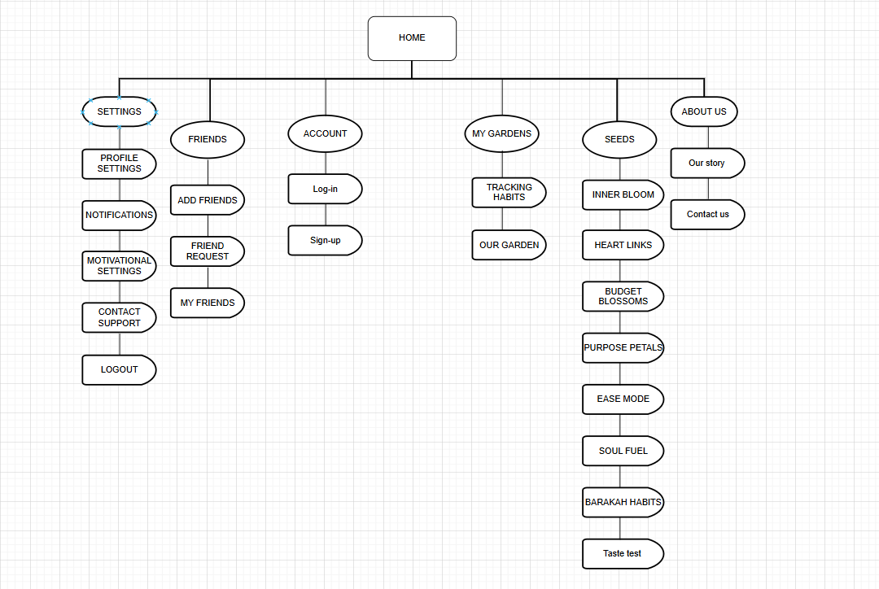e-

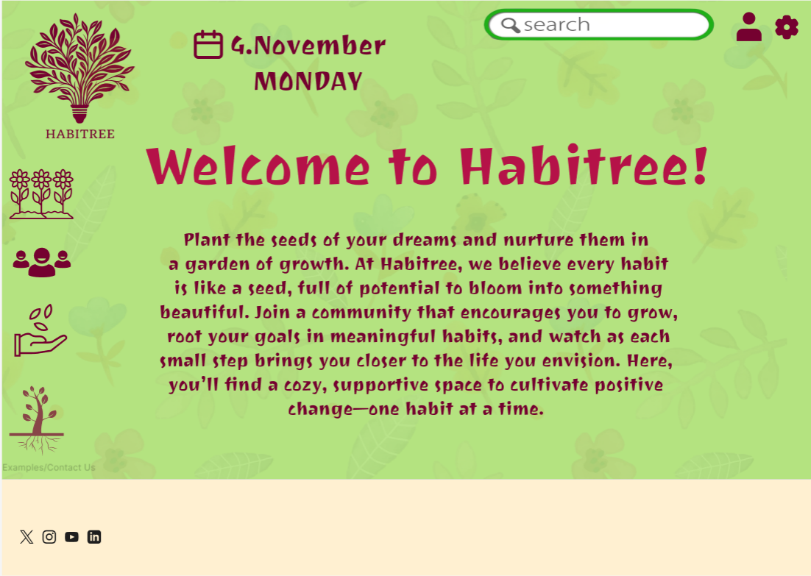

f-

**HOME PAGE**

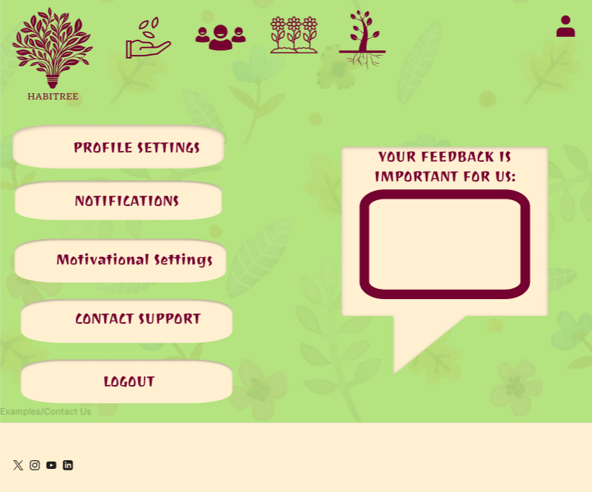

**SETTINGS**

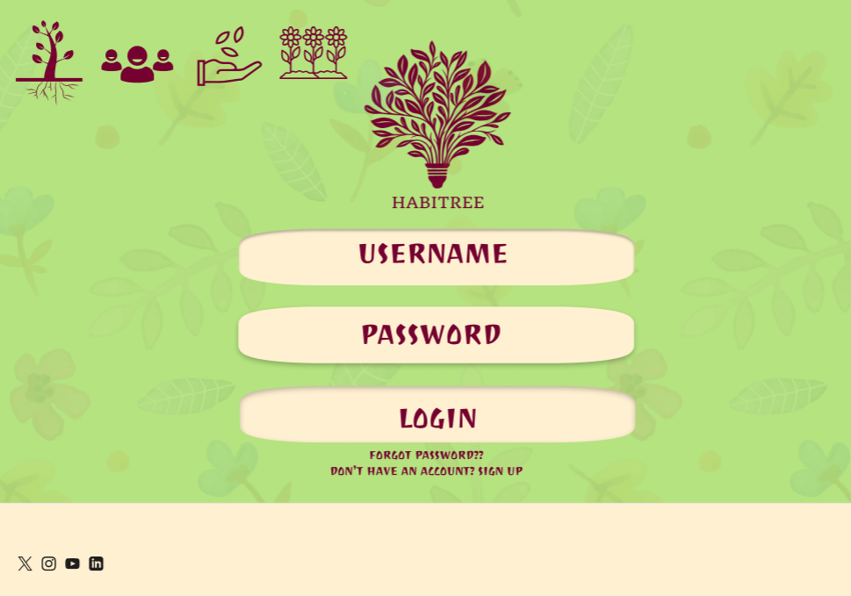

**ACCOUNT**

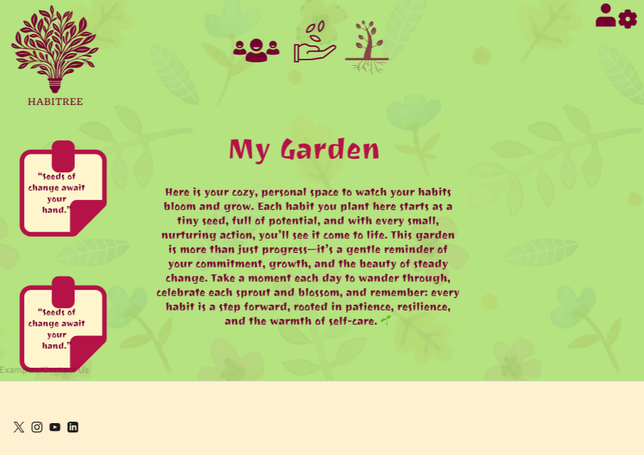

**FRIENDS**

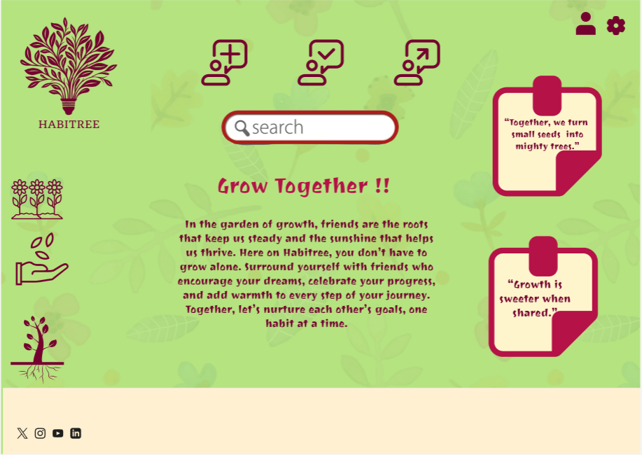

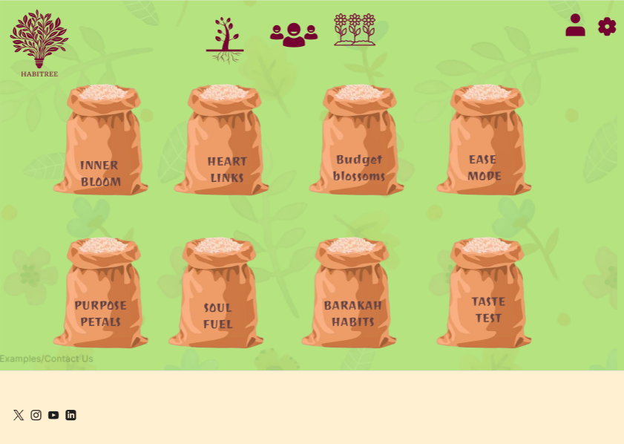

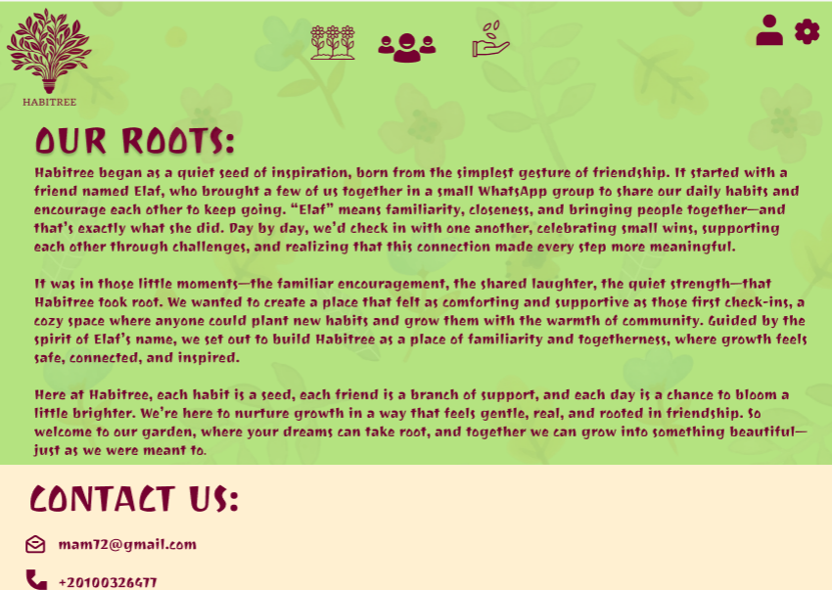



**OUR ROO**

2.3.2: Website Design.

### **1. Law of Prägnanz (Simplicity)**

* The overall layout is clean and straightforward, with icons and text arranged clearly. The simple color palette and use of whitespace help reduce visual complexity, making it easy for users to focus on the main content.

### **2. Closure**

* In the “Pick Your Seed” and “My Garden” sections, users visually complete the idea of the seed bags and garden plots. Even though they are simply icons and shapes, users mentally complete them as full concepts, like growth plots or bags of seeds.

### **3. Symmetry and Order**

* Symmetry is evident in the arrangement of elements, especially in the login and settings pages. Buttons are evenly spaced, icons are aligned, and text blocks are centered, creating a sense of balance and order.

### **4. Figure/Ground**

* The background has a soft, nature-inspired design, while important elements like buttons, icons, and text are clearly defined in contrasting colors (e.g., cream buttons on green backgrounds). This allows the primary elements to stand out as “figure” against the “ground.”

### 

### **5. Uniform Connectedness**

* Related elements, such as the icons in the header and buttons in the settings, are grouped together by similar colors and styles. This connectedness helps users associate these elements as related functions.

### **6. Common Region**

* The sections on each page, such as “Our Roots” and “Grow Together,” have distinct boundaries with clear background colors and spacing, which define them as separate regions.

### **7. Proximity**

* Elements that belong together, like the habit categories in the “Pick Your Seed” page, are placed close to each other, signaling their relationship and making navigation intuitive.

### **8. Continuation**

* Icons in the navigation menu provide a continuous flow from one function to the next, guiding the user’s eye from left to right. Similarly, the layout of buttons and text directs users smoothly down the page.

### **9. Common Fate (Synchrony)**

* Interactive elements such as buttons change in appearance when hovered over or clicked, providing visual feedback and reinforcing their function.

### **10. Parallelism**

* Parallel elements, like rows of buttons or aligned icons, create visual rhythm. This is seen in the symmetrical arrangement of buttons in the settings menu and seed bags on the “Pick Your Seed” page.

### **11. Similarity**

* Icons and buttons share similar shapes, colors, and styles across the website. For example, action buttons all have rounded, cream-colored backgrounds, making them easily recognizable.

### **12. Past Experience**

* Familiar symbols (e.g., the profile and settings icons) make navigation intuitive based on users’ past experience with other websites. The layout, with a search bar at the top, also leverages familiar website structures.

b-Deployment:

1- 1440 x 1240

2-







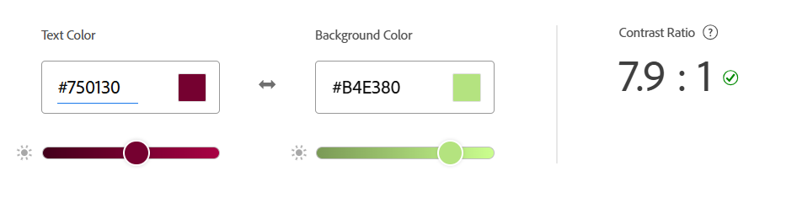

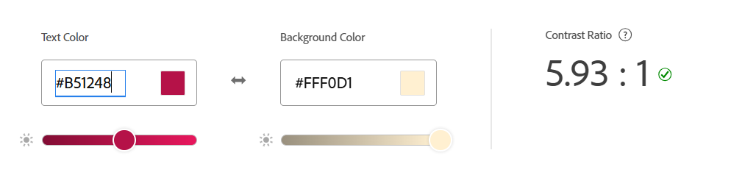

4-**Front-End Development Technologies:**

**HTML**: Core for structuring your pages, defining headings, text, images, and icons for each section of your website.

**CSS**: Essential for styling elements, creating your nature-inspired color palette, and maintaining consistent design aesthetics across the site.

**JavaScript**: Needed to add interactivity, such as button animations, dynamic habit progress updates, and interactive features like “watering” friends’ plants or unlocking rewards.

5-**Content Management System (CMS)**

**Strapi:**as a headless CMS, gives you full control over how you manage and organize content. You can easily set up and manage habit categories, motivational quotes, user profiles, and community posts.

6-**Back-End Development Technologies**

**Node.js with Express**: For handling the server-side logic, creating RESTful APIs, and supporting real-time interactions if necessary.

**MongoDB**: A NoSQL database that pairs well with Node.js and is flexible enough for storing user habits, progress, and community data.

7-**Metrics For Measuring Website Success**

**User Experience and Engagement :**

**Page Load Time:** Measures the time it takes for *Habitree* pages to fully load.

**Bounce Rate:** Monitors the percentage of users who leave after viewing just one page.

**Average Session Duration:** Measures how long users stay on *Habitree* during each visit.

**Retention rate :** Measures how many users return after their first visit.

**Website Reliability and Performance:**

**Error Rate:** Tracks the percentage of user interactions that result in errors (e.g., failed habit updates).

**Server Response Time:** Monitors how quickly the server responds to user requests.

**Mobile Performance Metrics:** Measures load time, usability, and interaction speed on mobile devices.

8-

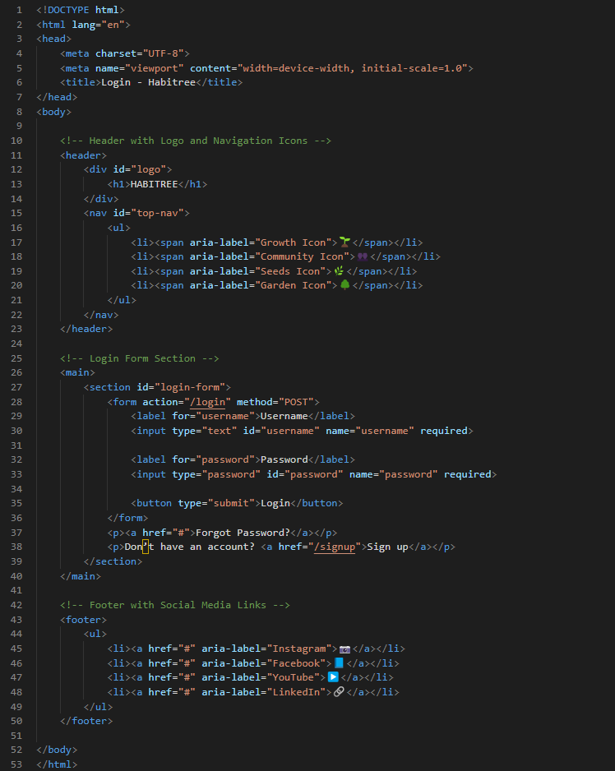



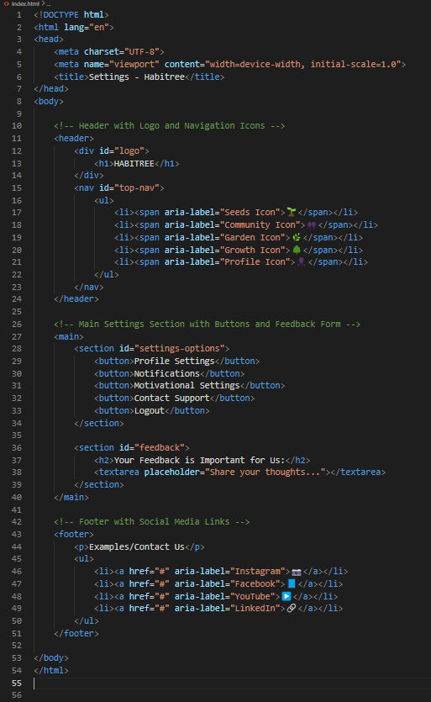

[1] “Web 2.0,” Techopedia. [Online]. Available: <https://www.techopedia.com/definition/4922/web-20> . [Accessed: Nov. 3, 2024].

[2] “Web 2.0,” Encyclopædia Britannica. [Online]. Available: <https://www.britannica.com/topic/Web-20> . [Accessed: Nov. 3, 2024].

[3] T. O’Reilly, “What Is Web 2.0,” O’Reilly Media, Sep. 30, 2005. [Online]. Available: <https://www.oreilly.com/pub/a/web2/archive/what-is-web-20.html> . [Accessed: Nov. 3, 2024].

[4] “What is Web 1.0 vs Web 2.0 vs Web 3.0 vs Web 4.0: Similarities and Differences,” Zolana, Aug. 15, 2023. [Online]. Available: <https://zolana.net/what-is-web-1-0-vs-web-2-0-vs-web-3-0-web-4-0-similarities-and-differences/> . [Accessed: Nov. 3, 2024].

[5] “Web 2.0 vs Web 3.0: What’s the Difference?,” BairesDev, [Online]. Available: <https://www.bairesdev.com/blog/web-2-vs-web-3/> . [Accessed: Nov. 3, 2024].

[6] “Decentralized web,” Wikipedia, [Online]. Available: <https://en.wikipedia.org/wiki/Decentralized_web> . [Accessed: Nov. 3, 2024].

[7] “The Web from 1.0 to 4.0,” KnowledgeOne, [Online]. Available: <https://knowledgeone.ca/the-web-from-1-0-to-4-0/> . [Accessed: Nov. 3, 2024].